Kelli Bowers, MPP
Michigan State University
Department of Political Science
May 2022
Data Gaps within the Missing and Murdered Indigenous Women’s Movement: Restructuring Data Collection Systems

Executive Summary

5,712. That is the number of known missing and murdered Indigenous women in 2016 alone. Only 116 of these cases were reported to the federal missing persons database, NamUs. A large gap exists between the data on missing and murdered Indigenous women (MMIW) that communities report versus how many cases are recorded by city law enforcement. Law enforcement agencies do not accurately track these cases, and 98% of the total number of cases comes from community/Indigenous reporting¹. The largest cause for this inaccurate case tracking by law enforcement agencies is the fact that no centralized reporting system exists. There are various ways of reporting missing persons cases, but they are not consistent, and they are complicated to use. Because there is not a centralized data collection system for MMIW, many cases fall through the cracks. A policy response that addresses the systemic lapses in inconsistent data collection systems can use the idea of Indigenous Data Sovereignty as a guiding value in creating more equitable data systems with Indigenous values at their core. If tribes are in control of their own data, the problem of MMIW data collection will be better advocated for, understood, and tracked.
Context/Problem

The major issue with the current criminal justice data collection systems is the lack of consistency and updates on Indigenous data. There is no standardized way of collecting data in any city, state, or federal police agency. There are complications with federal/tribal/and state jurisdictions depending on race, severity, and location of the crimes committed against Indigenous people (Figure 1). The largest federal, centralized database for missing persons is called NamUs. NamUs is a national information resource center for missing persons across the United States. It is funded and administered by the National Institute of Justice, and all NamUs resources are provided at no cost to law enforcement, medical examiners, coroners, allied forensic professionals, and family members of missing persons². Though NamUs is available in all 50 U.S. states to utilize for free, not all states are required to report their missing persons through the database. In fact, only ten states are required to report missing persons through the NamUs³. Because of this, thousands of MMIW fall through the cracks of this broken reporting system. The National Crime Information Center (NCIC) also exists for reporting, but it comes with its own complications. NCIC is not restricted to just missing persons data, but also includes data on all crime related matters like criminal record history, fugitives, stolen property, etc… This can become confusing for users trying to access a particular form of data. On top of this confusion, it is available only to law enforcement agencies to use, and all NCIC records are protected from unauthorized access⁴. Agencies cannot access files without going through an application process and obtaining an identification number. However, tribes have some access to NCIC through the Tribal Access Program (TAP). TAP was created so tribes can utilize the system as a logistical database and exchange critical data across the criminal justice information services systems, but currently there are only 108 out of 574 tribes participating in TAP⁵. This could be from barriers to access; Tribes are required to apply for access, and there is an application period that closes for part of the year.
In the case of MMIW, them Native American race often does not show up in data collection systems. There is often not a space to select “Indigenous” or “Native American” on data collection services within policing data and reporting systems¹. These data gaps

Page | 1

_______________________________________________________________________________________

Figure 1: Jurisdiction Table, 2022
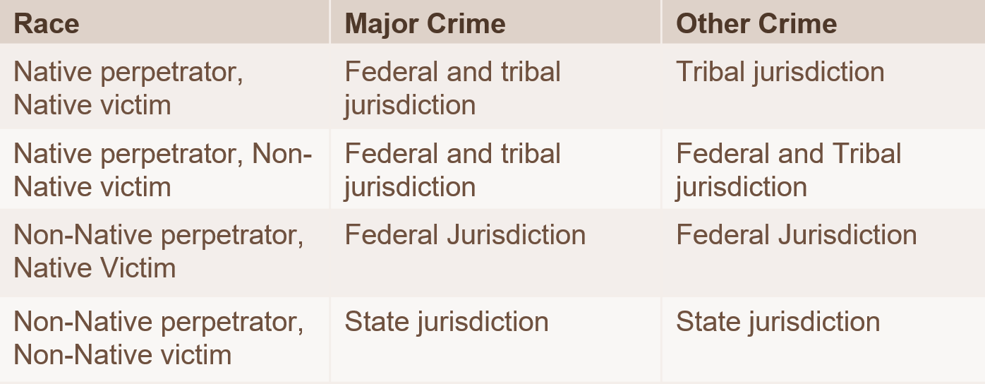
that exist are a form of genocide; of erasing entire groups of Indigenous nations and groups of women that have so much to offer the world. The disregard is not accidental. When these cases occur, there is human agency in how the cases are handled, how they are recorded, how they are followed through with. These cases take police officers, medical examiners, investigators, reporters, and more to correct this inaccurate reporting. Humans that are documenting do not always care enough to record accurately, follow up on cases, etc… That very local level where the data are collected is where it starts.
Keeping these complications in our data collection systems in mind, all these systems make it difficult for tribes to have access to their own data. This only exacerbates the idea that tribes need to be granted permission from the government to access their own data on their missing/murdered people. As a society, we have decided that the issue of Indigenous women and girls being counted is not an important enough issue to be addressed. We have continued to turn a blind eye to the invisibility of MMIW and have shown that they are disposable in our society. Data collection is arguably the most powerful way the United States government structures power. Policies, especially progressive ones, are often not passed unless there is quantifiable data to support them.

Analysis

Part of the analysis was examining data gaps that exclude Indigenous women within the criminal justice systems in the US. Two Indigenous scholars – Abigail Echo-Hawk (Pawnee), MA and Annita Lucchesi (Southern Cheyenne), PhD-c¹ conducted a study at the Urban Indian Health Institute in 2018. The graph shows the 2010-2018 Tracking of MMIW Cases in 10 Cities with Highest Number of Cases not in Law Enforcement Records (Figure 2). The cities listed in Figure 2 are the cities with the highest number of MMIW cases that are not in law enforcement records. In all instances, except for two (Seattle and Anchorage), communities reported more cases than did city law enforcement agencies, showing immense gaps. Some inconsistencies in the systems include considerably massive data systems that combine large amounts of data, records being protected from public usage, long application processes, the inability to search for American Indian or Native American in reporting systems, and non-mandatory reporting for police officers¹. Through a combination of all these discrepancies, it is clear law enforcement agencies are not tracking cases accurately, and that tracking is often left in the hands of community
Page | 2
_______________________________________________________________________________________

Figure 2: Inaccurate Case Tracking by Law Enforcement, 2018. Source: Urban Indian Health Institute.

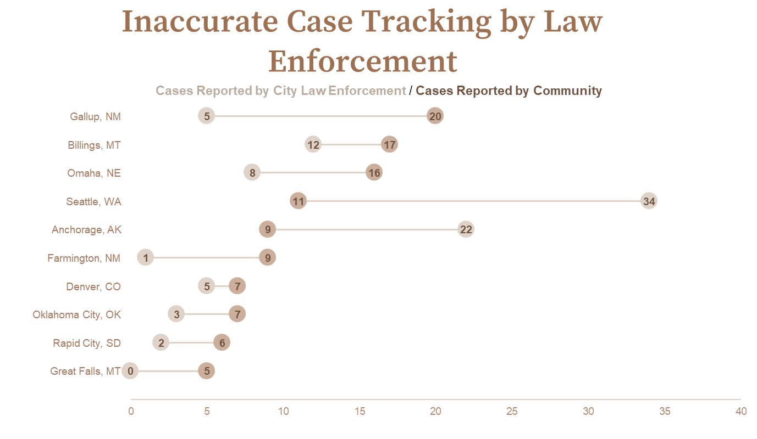

members to self-report. The number of cases reported by community members were found through a pooled group of sources, such as new reports, social media, advocacy websites, and direct contact with family and friends¹. Therefore these numbers are likely still a severe undercount of how many cases have not been reported at all, which adds more complications to the MMIW movement. Because no centralized, mandatory database for tracking MMIW cases exists, data collection is extremely difficult for both law enforcement agencies and community members.

Implications and Recommendations

Native Americans, though technically sovereign people with sovereign lands, remain infantilized through a pattern of federal oversight policies, such as prohibiting tribes from owning and collecting their own data. Even though Indigenous peoples are “no longer designated enemies of war, American Indians are still treated as a population in need of federal oversight”⁶. Individual tribes are always in the best position to capture the issues and care for their own peoples. The idea of Indigenous data sovereignty (IDS) has emerged as a solution to the colonized system of data collection that has led to these data gaps in the MMIW movement⁷. According to the United States Indigenous Data Sovereignty Network, “Indigenous data sovereignty is the right of a nation to govern the collection, ownership, and application of its own data. It derives from tribes' inherent right to govern their peoples, lands, and resources⁸.”
An option to accomplish Indigenous data sovereignty would be to restructure our current data collection systems to reflect more Indigenous values at their center. A centralized data collection system in all 50 states from all levels of government is a short-term recommendation and a stepping stone on the way to Indigenous data sovereignty. This might look like an expansion of the NamUs system, in which all law enforcement agencies in every state are mandated by law to report all missing persons cases. Once the data is more reliable through a national centralized system, the idea is that then Tribes who wish to do so can have a reliable source of data to build from and can create their own sovereign data systems in which they can govern the collection, ownership, and application of their own data
Page | 3
Therefore, a longer-term policy solution is a brand-new national data collection system that is created to specifically focus on Indigenous peoples that all tribes can access without barriers or complications. The Sovereign Bodies Database could help with this recommendation. It is the first Indigenous created and owned international database for MMIWG and two-spirited people⁹. Tribes would not have to do any additional auditing or applications in the process. Instead, U.S. government officials would have to conduct a formal request to access the data at the discretion of the Indigenous researchers who maintain the database. This could be the backbone of the eventual Indigenous data sovereignty governance system. By continually adding to and spreading awareness of this system while simultaneously working with local, state, and federal governments with agreements for collaboration or simply transferring data cases, this database could be the outline for that shift in power.

These thousands of women and girls who have gone missing or been murdered are humans with stories, families, cultures, and traditions. They mean so much more than a number, and their stories must be shared. This means having more accurate representation in media outlets, instead of victim-blaming and reinforcing stereotypes. It means listening to tribes, hearing their stories, and making sure they are known and respected if the family/tribe wishes to share. This means their data is protected, respected, and closely held in the hands of the tribes themselves, only to be shared if those tribal nations specifically wish to do so. Decolonizing data means Indigenous and tribal nations are leading the conversations with the successes and feats in their communities and beyond. It means changing the narrative and the power dynamic to Indigenous peoples taking back their power, stories, and data.

Page | 4

End Notes
- Echo-Hawk, Abigail and Annita Lucchesi. 2018. “Missing and Murdered Indigenous Women and Girls: A Snapshot of Data from 71 Urban Cities in the United States.”Urban Indian Health Institute.
- Retrieved from https://namus.nij.ojp.gov/
- Spencer, C. (2021, April 29). Is NamUS Reporting Required In Your State? Here’s A Look At State Legislation On The Missing & Unidentified Persons . Retrieved from https://www.biometrica.com/is-namus-reporting-required-in-your-state
- Pike, J. (2008, June 2). National Crime Information Center (NCIC). National Crime Information Center (NCIC) - FBI information systems. Retrieved April 30, 2022, from https://irp.fas.org/agency/doj/fbi/is/ncic.htm
- Retrieved from https://www.justice.gov/tribal/tribal-access-program-tap
- Carroll, S.R., Rodriguez-Lonebear, D. and Martinez, A., 2019. Indigenous Data Governance: Strategies from United States Native Nations. Data Science Journal, 18(1), p.31. DOI: http://doi.org/10.5334/dsj-2019-031
- Rodriguez-Lonebear, D. 2016. Building a data revolution in Indian country. In: Kukutai, T and Taylor, J (eds.), Indigenous data sovereignty: Toward an agenda, pp. 253–272. Canberra, Australia: Australian National University Press. DOI: https://doi.org/10.22459/CAEPR38.11.2016.14
- Retrieved from https://usindigenousdata.org/
- Retrieved from https://www.sovereign-bodies.org/mmiw-database

